Gallatin Local Water Quality District
Surface Water Monitoring Program
Standard Operating Procedures



March 2019

Prepared by:
Torie Haraldson, Water Quality Specialist
Gallatin Local Water Quality District
Bozeman, Montana

Revisions
Date | Page(s) | Revision Notes
4/22/22 | throughout | Updated YSI models used and associated use and maintenance instructions.
 | 20 | DEQ SOP references updated.
5/19/22 | Section 2.5 | Updated and clarified instructions for using the OTT MFPro in Profile mode.
5/15/2023 | Throughout | Updated Surface Water Site Visit Form. Updated YSI model used and removed old models. Added additional analytes. Removed Marsh-McBirney flow meter, added FlowTracker2 meter. Added Visual Algae Assessment Form.
3/27/2025 | Throughout | Minor language changes, changed ‘Attachments’ to ‘Appendix’ updated Appendix B: YSI Maintenance & Long-term Storage, added Appendix F.

Table of Contents
1 Introduction 4
1.1 Overview of Monitoring Event Activities 4
2 Protocols 4
2.1 Project logbook 5
2.2 Instantaneous Field Measurements using a YSI Meter 5
Inspection, Maintenance and Long-term Storage 5
Calibration 5
Field Measurements 5
2.3 Grab Sample Collection 7
Sample Labeling 7
Sampling Procedure 7
Field Duplicate Samples for Quality Control 8
Field Blank Samples for Quality Control 8
Sample Shipment 9
2.4 Staff Gauge Siting and Stage Measurement 10
Gauge Siting 10
Stage Measurement 11
2.5 Stream Discharge Measurement 11
Calculating Stream Subsections (for use with the Stream Discharge Form) 12
Streamflow measurements with the OTT Meter 12
Streamflow measurements with the FlowTracker2 14
Discharge Calculation 16
Rating Curve Development 16
2.6 Turbidity 17
2.7 Wollman Pebble Count 18
2.8 Photo Documentation 19
2.9 Macroinvertebrate Samples 20
EMAP Methodology 20
Field Replicates 23
Modifications 23
References 25
Appendix A: Example Field Forms 26
Appendix B: YSI Maintenance & Long-term Storage 34
Appendix C: YSI Calibration Instructions and Calibration Log 41
Appendix D: TruTrack Cleaning Instructions 44
Appendix E: TruTrack Water Level Calibration Instructions 46
Appendix F: Solinst Levelogger and Barologer Data Download and Compensation Instructions 47

Introduction

This Standard Operating Procedures (SOP) document describes the field protocols for physical, chemical, and biological data collection and processing associated with surface water monitoring projects undertaken by the Gallatin Local Water Quality District (GLWQD). This SOP will be reviewed and modified as necessary to meet the goals of specific programs. Modifications will be documented in the Revisions table at the front of the document.

The guidelines and requirements for quality assurance and quality control for these monitoring protocols will be outlined in the Quality Assurance Project Plan (QAPP) or Sampling and Analysis Plan (SAP) for the project to which they will be applied.

Members of any field team collecting data for GLWQD-led projects should contact the GLWQD staff member serving as the project’s technical advisor any time questions regarding field sampling and monitoring procedures arise.

1.1 Overview of Monitoring Event Activities

While the specific protocols used will vary from project to project, it is always important to organize activities spatially and temporally to minimize disturbance effects from one activity on another.

- Complete activities that are sensitive to disturbance (grab samples, YSI measurements) and/or typically result in minimal stream disturbance (photos) upstream of activities that cause and/or are relatively unaffected by disturbance (e.g., flow measurements, pebble count).
- Allow a brief waiting period between activities so that flow can clear any disturbance from the study reach.
- When collecting data on multiple sites on a single water body, work downstream to upstream whenever possible.

Protocols

The following are protocols typically used in GLWQD surface water monitoring projects. Not all protocols will be used for every project. For more details, consult the QAPP or SAP for the project of interest.

A Site Visit Form and other data collection sheets are noted in the supply list for most protocols. The specific content and layout of these forms can vary from project to project and will be provided with the project QAPP/SAP. However, examples are included for reference with this document (Attachment A).

2.1 Project logbook

A field logbook should be maintained during the course of any project. It should contain notes and observations on each site visit, including:
  - Site visit time
  - YSI and turbidity measurements
  - Samples taken and sample IDs
  - Staff gauge readings
  - Condition of staff gauge, stilling well, and continuous stage instruments
  - Photo JPEGS
  - Any other pertinent information

2.2 Instantaneous Field Measurements using a YSI Meter

Inspection, Maintenance and Long-term Storage

GLWQD currently uses a YSI ProQuattro model. The ProQuattro must undergo annual inspection and maintenance prior to the field season. Any meter intended for use in the upcoming season must be taken out of long-term storage and inspected for necessary repairs or part replacements prior to use. YSI inspection, maintenance, and long-term storage procedures are outlined in Attachment B.

Every other year, send meters to a certified service provider to be inspected, tested and, if necessary, repaired. This must occur within a time-frame that provides a cushion for the service provider’s turn-around time and shipping, so contact the service provider well in advance of the date needed.

Record all inspection, maintenance, and/or repair actions in the Calibration and Maintenance Logbook kept with each meter.

Calibration

The YSI will be calibrated on the first day of a sampling event prior to use, and a drift-check performed daily after use. The calibration and drift-check procedures and calibration log sheets are included in Attachment C.

Field Measurements

Supply List:
- YSI meter, inspected and calibrated
- DI water
- KimWipes
- Tap water
- Calibration standards and spare DO membrane kit (conveniently available, not necessary to bring streamside)
- Site Visit Form (example, Attachment A)

- On a properly inspected and calibrated meter, install probe sensor guard in place of the calibration/transport cup. If possible, retain water in transport cup.
- Turn on the meter by pressing the green power button and allow it to cycle on.
- Wade with the meter into the water just below the location where field measurements will be collected. This location should be in a well-mixed portion of the channel where the water is steadily flowing, and deep enough such that the sensors can be entirely submerged in water. Avoid stagnant water and eddies, and areas that are excessively turbulent.
- Stand in place or return to the bank with the display unit, leaving the probes instream.
- When the readings have stabilized, record all those indicated on the Site Visit Form.
- Turn off meter, remove probe from the stream, and remove sensor guard. Inspect probes for grit or debris, and carefully rinse with DI water, if necessary.
- Replace transport cup with about 1/8 inch of tap or stream water (NOT DI water) in the calibration/transport cup on the probe.
- Return all parts to carrying case. Do not disconnect probe cord until end-of-day drift checks are complete. The drift check procedure varies with meter model, and is described in the calibration log kept with the individual meters.

2.3 Grab Sample Collection

Water samples to be collected are project-specific, but might include total suspended solids (TSS), nutrients (total persulfate nitrogen, nitrate-nitrite as nitrogen, total phosphorus, orthophosphate, and ammonia), and/or E. coli bacteria. Sample bottles and preservatives are also project-specific and are typically provided by the lab(s) contracted for analytical services. The parameters and the associated analysis methods, reporting limits, hold times, and required preservatives will be summarized in the project’s guidance documents (Quality Assurance Project Plan or Sampling Analysis Plan).

Sample Labeling

Each sample must have a unique identifier. GLWQD projects will use the following sample ID nomenclature:

MMDDYY-TTTT-EGAL01-A

Sampling Event Date Event Time Location ID Sequential Letter
Month = 1st and 2nd digits Military time: Station ID. A = field sample
Day = 3rd and 4th digits 0800 for 8am, See project QAPP/SAP B = duplicate sample
Year = 5th and 6th digits 1300 for 1pm, etc. for designations. C = DI water blank

Sampling Procedure

Supply List:
- Sample bottles and preservatives
- Waterproof pen
- Cooler with ice
- Nitrile gloves (for E. coli samples)
- Site Visit Form (example, Attachment A)
- DI water for field blanks
- Filtration supplies (in the event samples requiring filtering are collected)
- Fill out the sample bottle labels using a waterproof marker (see Sample Labeling section).
- If collecting an E. coli sample, put on nitrile gloves.
- Stand facing upstream in the center of the stream (or as close as safely possible) and upstream from any previous disturbances to avoid contaminating the sample.
- If collecting an E. coli sample, proceed to Step 5. For other unfiltered analytes, rinse sample bottles 3 times with stream water by partially filling the bottle, placing the lid over the bottle, shaking several times, and pouring the water out downstream (behind you). For field filtered samples, proceed to Step 6.
- Submerge the sample bottle upside down, righting it underwater so the mouth of the bottle is below the surface (to prevent floating surface particulates from entering the bottle) and above the bottom (to prevent substrate from entering the sample bottle). If collecting an E. coli sample, carefully tip water out of the bottle until full to the 100mL line.
- For samples requiring field filtration, pull stream water collected below the surface (to prevent floating surface particulates from entering the bottle) and above the bottom (to prevent substrate from entering the sample bottle). Rinse sample bottles 3 times with a small amount of filtered water before filling it with filtered water, using fresh filters as necessary when it becomes too difficult to push water through the filter membrane.
- Recap tightly.
- Return to the bank and add the appropriate preservative to each sample type (sample bottle and preservative cap colors are typically color-coded), pouring off a small amount of water if necessary to make room for the preservative. Recap securely and mix the preservative into the sample by gently inverting 3-5 times.
- Place sample bottles in Ziplock bags and place upright in a cooler on ice. Record the sampling event on the Site Visit Form.
- Place samples in a fridge set to maintain required temperature (see project SAP) unless shipping at the end of the sampling day.

Field Duplicate Samples for Quality Control
- Collect duplicate samples (sets) following EXACTLY Steps 1-10, above. This will result in two sets of stream samples being collected at one site.
- Include a remark in the comment section of the Site Visit Form that a duplicate was collected at this site and include the Sample ID for the duplicate as a reference.
- Include field duplicates on the chain-of-custody form and ship with other samples to the laboratory.

Field Blank Samples for Quality Control
- Transport DI water to the sampling site and keep in a location where it will not be exposed to excessive dust or mud, or come in contact with other equipment.
- Follow Steps 1-10, above. EXCEPT use DI water instead of stream water for all steps.
- Include a remark in the comment section of the Site Visit Form that a blank was collected at this site and include the Sample ID for the blank as a reference.
- Include field blanks on the chain-of-custody form and ship with other samples to the laboratory.

Sample Shipment

Samples should not be shipped on Fridays unless approved in advance by the lab.

Supply List:
- Cooler to be shipped with ice and sample bottles that have been filled and preserved
- Laboratory Chain of Custody (COC) form (provided by lab)
- Shipping label and custody seal (provided by lab)
- Temperature blank (provided by lab)
- Waterproof pen
- Additional ice, as needed to maintain required temperature (see project SAP) until received by the lab
- 1-gallon Ziplock bags
- Site Visit Form (example, Attachment A)
- Clear Packing tape

- Place enough ice in 1-gallon Ziplock bags to line the bottom of the shipping cooler.
- Nestle temperature blank in ice in cooler.
- Open each sample set Ziplock and confirm that lids are tightened securely. Copy sample IDs and requested analysis on the COC form before resealing the sample set bag and placing sample bottles in the cooler.
- Once all samples are in the cooler, add additional ice in Ziplock bags as needed to maintain required temperature (see project SAP) until received by the lab.
- Complete the COC form.
- Retain copy of complete COC for GLWQD records. Place lab copies in the provided Ziplock bag and tape to the inside of the cooler lid.
- Place shipping label on cooler lid and completed custody seal on cooler lip.
- Tape cooler closed, making two complete passes around the entire cooler, and securing the shipping label and custody seal.
- Record sample shipment on the Site Visit Form.
- Relinquish to shipping company identified on shipping label (FedEx or UPS).

2.4 Staff Gauge Siting and Stage Measurement

Gauge Siting

The ideal gauge site satisfies the following criteria (from Rantz et al. 1982):
  - The channel is generally straight for approximately 100 meters up- and downstream from the site.
  - The total flow is confined to one channel at all stages; no flow bypasses the site as subsurface flow.
  - The streambed is not subject to scour and fill and is free of aquatic growth.
  - Banks are stable, high enough to not be easily topped, and are free of brush.
  - Unchanging natural controls are present in the form of a bedrock outcrop or other stable riffle for low flow and a channel constriction for high flow-or a falls or cascade that is un-submerged at all stages.
  - A pool is present upstream from the hydraulic control to ensure recording of stage at extremely low flow and to minimize the effects of high water velocities on the instrumentation.
  - The gauge site is far enough upstream from the confluence with another stream or lake inlet to avoid a variable back water influence upon stage.
  - A satisfactory reach for measuring discharge at all stages is available within reasonable proximity of the gauge site (it is not necessary that low and high flows be measured at the same stream cross section).
  - The site is readily accessible for ease in installation and operation of the instrumentation.
  - Since the digital stage recorder measures fluctuation of the water surface elevation it needs to be deployed in a location where the stage-discharge relationship is relatively constant. An ideal monitoring location will have both section and channel controls. A section control occurs where a break in slope or reduction in channel geometry downstream of the monitoring site regulates low flow stage. A channel control occurs where channel morphology (i.e. the combination of size, slope, roughness, alignment, constrictions and expansions, and shape of the channel) dictates the stage-discharge relationship at high flows. Most natural channels have compound controls, that is, section controls at low flow and channel controls at high flows. Note that reach-scale channel gradient and the length of the reach under channel control are generally negatively correlated.
  - The hydraulic controls downstream of the site should be both stable and sensitive. For example, natural accumulations of wood downstream of the gaging site provide an unstable control since they may aggrade or degrade under varying flows. Adjustable man-made flow control structures (i.e. irrigation head-gate) located downstream of the site are unstable controls since variability in their operation may influence the stage-discharge relationship of the upstream channel section. Compared to other channel locations, sensitive controls (i.e. sections with relatively narrow width to depth ratios) result in greater changes in water depth per unit increase in stream discharge.
In summary, the ideal monitoring location consists of a pool in a relatively straight section of the channel having a stable and sensitive natural bed-form (e.g. well-developed downstream riffle or bedrock outcrop) as a section control and a downstream geomorphic constriction as a channel control. In many cases, ideal gauge placement cannot be achieved, but care should be taken to satisfy the criteria listed to the greatest extent possible.

Stage Measurement

Continuous stage (water height) measurements provide a means to calculate continuous discharge (a.k.a. “flow”, measured in cubic feet per second, or “cfs”) when paired with manual stream discharge measurements to develop rating curves. Accurate rating curves depend on a sufficient number of accurate manual discharge measurements, taken at a full range of high and low stream flows.

Manual stage readings should be taken from a staff gauge marked in tenths of feet, located on or near a stilling well instrumented with continuous stage measurement equipment. Readings should be made at each site visit throughout the study season to capture peak, tailing, and baseflow hydrograph conditions.

The use of digital stage recorders (DSRs) will be done following the procedures outlined in Montana Department of Environmental Quality’s document WQPBWQM-007, Standard Operating Procedure for Digital Stage Recorders.

GLWQD currently uses Solinst brand transducers paired with barometers to correct for changes in pressure. However, TruTrack brand DSRs might be used in certain circumstances. TruTracks should be cleaned and water level calibrated according to manufacturer instructions (Attachment D and E) prior to deployment.

Cleaning (Attachment D): Cleaning should be done every 6 months at a minimum, more frequently if deployed in dirty/silty water.

Water Level Calibration (Attachment E): Calibration should be done annually, prior to deployment.

2.5 Stream Discharge Measurement

Supply List:
- 100’ reel-type tape measure
- 2 bank pins
- hammer
- Top-setting rod
- FlowTracker2 or OTT flow meter
- Stream Discharge Form (example, Attachment A)
To ensure an accurate stream discharge measurement, no more than 10% of total stream discharge (depth x velocity) should be measured in a single subsection. When using the OTT meter in Profile mode, this can be done using experience and judgement, and corrected by reviewing the stored data in the stream discharge profile and adding additional subsection measurements as needed.

If working in a team and using the Stream Discharge Form (as with Gallatin Stream Teams), the confusion of adding additional subsections at the end of the profile can usually be achieved by dividing the stream width into 20 equal subsections on the form before beginning the in-stream work. Every effort should be made to capture no more than 10% of total discharge in a single depth/velocity measurement. In streams where the areas that are deepest are also fastest moving, consider narrowing the distance between measurement points in these areas.

Calculating Stream Subsections (for use with the Stream Discharge Form)
- Choose a section of relatively straight channel, with uniform flow and no undercut banks or backwater areas, preferably where flow is not turbulent or in a riffle.
- String the measuring tape across the stream perpendicular to the flow and secure the tape with bank pins.
- Record the measurement on the tape at the left and right wetted edges in tenths of feet on the Stream Discharge Form and determine the wetted width (WW) of the stream channel by subtracting the left wetted edge measurement from the right.
- Divide the wetted width by 20 to determine the maximum distance between measuring points. Round distances down to the nearest tenth and record them on the form. You should have a minimum of 20 measurements unless the channel is too narrow to space the points 0.2 feet apart. In this case, take as many measurements as you can at a 0.2 foot spacing.

Ex: WW = 25.0 ft. 25.0 / 20 = 1.25 ft. Round down to 1.2 ft.

- Start at the wetted edge with the lowest tape measurement and record it in the first row of the form, filling in rows until you enter the tape measurement at the opposite bank. You should have at least 21 rows filled in.
- Move on to streamflow measurements with the OTT or FlowTracker2.

Streamflow measurements with the OTT Meter
- Attach the sensor to the top setting rod. Make sure the meter is parallel to the stream so that the cord comes out the top of the meter, and that the thumb nut that attaches the sensor to the top setting rod is very tight.
- Push the power button until an audible beep is heard – a self-test will run. Select OK after self-test is complete (battery voltage must be greater than 3.4v)
- Click on “Profiler”, then enter operator’s initials and click OK.
- Click “Stream”, then enter the stream name abbreviation and click OK.
- If there’s a staff gauge present, enter the staff gauge height under “Stage Reference”. If not available enter 0 and click OK.
- The screen should now say “Station 1” at the top.
- Click on “Edge/Obstruction”, then choose Edge (right or left while looking downstream) and click OK.
- Click on “Dist. To Vertical” and enter the tape reading at the edge and click OK.
- If depth at the edge is 0, proceed to Step 10. If the edge has depth > 0 (such as a vertical bank or wall), proceed to Step 12. NOTE: After setting depth > 0 at an edge, an Edge Factor menu appears. Select from the list below, then click OK.
- 0.5 to 0.6 = rough walls
- 0.7 = brick sides w/vegetation
- 0.8 to 0.9 = rough walls with heavy vegetation
- Click “next” at the bottom of the screen. The screen should now indicate you have advanced to the next station. (NOTE: You do not need to change the Edge tab again until you reach the other side of the stream, as it will auto-advance to Open Water.)
- Click on “Dist. To Vertical” and enter the tape reading at the edge and click OK. If working with a partner, they can read this to you from the Stream Discharge Form.
- Click on “Set Depth” and enter the depth read from the topsetting rod and click OK. Repeat the depth to your partner to record on the form. (NOTE: Each single mark on the rod represents 0.10 foot, each double mark represents 0.50 foot, and each triple mark represents 1.00 foot. You may estimate to the nearest 0.05 feet – ½ way between single marks)
- Adjust the topsetting rod so the sensor is at 60% of stream depth. (Ex: If stream depth is 2.7 feet, then line up the 2 on the sliding rod with the 7 on the stationary scale at the top of the rod.)
- Click on “Measure Velocity”, then on “One Point”, then click OK.
- Stand still with the rod oriented vertically and perpendicular to flow, then click “Capture”. Wait until meter indicates progress = 100%. Read the velocity to your partner.
- Repeat Steps 10-15 until the opposite bank is reached.
- At opposite bank, repeat Steps 7 and 8. If depth at the edge is 0, proceed to Step 18. If the edge has depth > 0, repeat Steps 12-15, then proceed to Step 18.
- Click “Channel Summary”, then click “Cont.” twice to view the Discharge Profile. If the top of the Y-axis (“% Dischrg.”) reads 10 or less (see blue circle in photo), read Flow in ft³/s to your partner and proceed to Step 19. If the top of the Y-axis (“% Dischrg.”) reads 11 or more, add additional flow stations where the red lines appear on the Discharge Profile. (See ‘Adding Stations’, below).
- Exit the channel summary by clicking OK, then “Save Data and Exit”.
- Delete the existing name with the delete button (bottom left button with an “x” inside an arrow).
- Enter the name of the stream abbreviation and the date (ex. CAMP511 for Camp Creek on May 11th). Some adjustments may need to be made to fit the name and date as there are only about 8 characters.
- Click OK, then click Done, and power off the OTT
Adding Stations
- Count the spaces between lines to determine the numbers on either side of a red line (Stations 3 and 4 in photo example). You will need to add a station here.
- Click OK to exit the channel summary.
- Hit “prev.” until you are at the station numbers of interest and check the tape readings (“Dist. to Vert.”) at both.
- At the lowest station of interest (3 in example photo), click “Ins.” (for insert) at the bottom, which will add a station in the correct place.
- Click “Dist. to Vert.” and add a tape reading between the stations of interest.
- Add depth and measure the velocity, quoting these values to your partner to record in the ‘Added Stations’ section on the Stream Discharge Form.
- Return to the Discharge Profile and repeat these steps until the top of the Y-axis (“% Dischrg.”) reads 10 or less (see blue circle in photo).
- Proceed with Step 19, above.
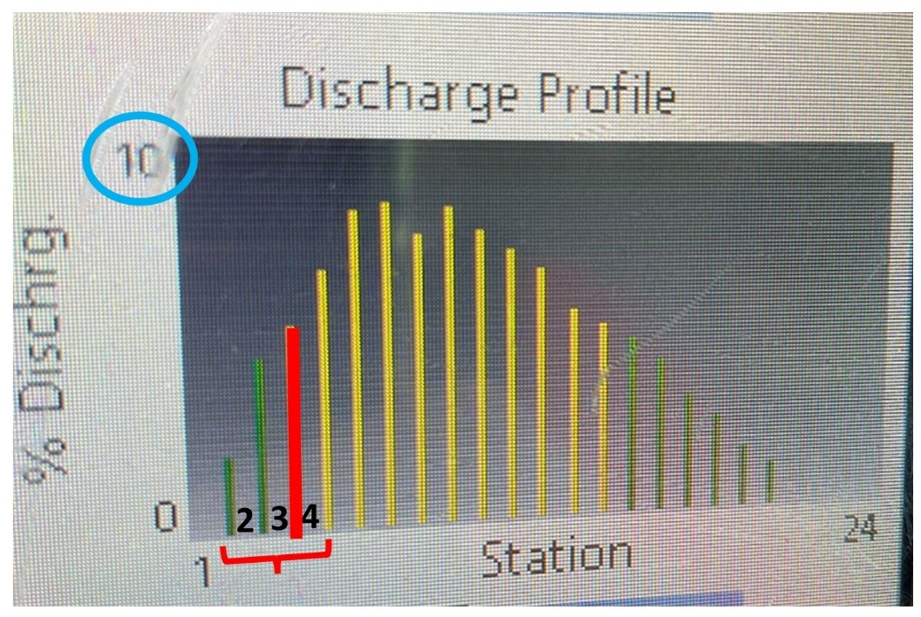
Picture of the Discharge Profile screen from the OTT MFPro.

Streamflow measurements with the FlowTracker2
- Screw together the wading rod. Start with the larger diameter rod, make sure arrows line up. Finish with the smaller diameter rod.
- Connect the ADV probe to the bracket on the wading rod using the included wrench. Make sure it is tight but not over tightened.
- Connect the cable to the handheld.
- Connect the handheld to the wading rod using the included bracket.
- Hold power button until screen comes on.
- To take a measurement, hit the right soft key. Then hit enter to take a discharge.
- For file type, use the default and hit enter.
- Arrow down to “Site Name”. Type in the site ID as it is shown on the site visit form and the date of discharge. Ex.) Dry Creek at Mouth sampled on April 24th, 2023, would be “DRYCMTH 4-24”.
- Arrow down, add operator’s initials.
- Hit right soft key for “OK”.
- For the first site of the day, complete an automated beam check (left soft key).
- Hit the left soft key to ‘add station’. The top banner should read “Add Station #1”
- Add location of either edge in “Location (ft)” arrow down and add depth (ft).
- Station 1 Station Type is Left Bank or Right Bank when looking DOWNSTREAM.
- Correction Factor is 1, hit right soft key to add station.
- Hit left soft key to add a station. Add location and depth, station type will be open water. ‘Velocity Method’ will be 0.6 for all depths.
- Hit the right soft key to take a measurement. The next screen will prompt you as to where to place the ADV Probe. Hit the right soft key to start the measurement, this will take 40 seconds.
- Once the measurement has been taken, hit the right soft key to accept the measurement.
- Repeat steps 17-19 until the opposite bank is reached.
- Once the penultimate measurement has been completed, hit the left soft key ‘Close’ to review the discharge bars. If any bars are red (greater than 10% of the total discharge) you will need to add a station to the left or right of the red bar (a good rule of thumb is to add the station half-way between the two existing stations).
- Repeat until there are no more red bars.
- To add the final station, add location and depth and change the station type to the opposite bank (there will be only one option for Bank location), with a correction factor of 1. Hit done (right soft key).
- Hit menu (right soft key) and hit enter to complete the measurement. Hit OK.
- The summary will populate, read off the discharge to the nearest hundredth. Hit Complete.
  - EX.) Q = 75.429 record on Site Visit Form and in the field notebook “Q = 75.43”
- Either turn off the handheld or put it to sleep if it is needed at the next site (hold the power button down until prompted to turn it off or press the power button once to put the handheld to sleep).

Discharge Calculation

The method used to compute discharge makes the following assumptions:
  - The measured depth at the mid-point of each section is considered to be the mean depth for the section.
  - The velocity measured at 60% of water depth is assumed to be the mean velocity for the respective section.
For each section, the discharge is the mean depth multiplied by the mean velocity. The section discharges are summed to obtain the total discharge through the gauging cross section.

These calculations are completed in real-time by the OTT MFPro and FlowTracker2 meter when in Profile mode, or from the Stream Discharge Form using an Excel spreadsheet set up for this purpose. Individual discharge calculations should be re-checked for accuracy at the end of the field season, and recorded on the appropriate Site Visit Form.

Rating Curve Development

A rating curve will be developed for each gauging station by plotting the manual stage vs. manual discharge measurements, and then fitting a line to the data. The mathematical techniques for line fitting are described in the U.S. Geological Survey manual entitled, "Discharge Ratings at Gauging Stations" (Rantz, S.E. et al. 1982), and should be applied to this task with the assistance of computer-based computations for curve fitting.

2.6 Turbidity

Turbidity is a measurement of how “cloudy” water appears, or an optical determination of water clarity. The turbidity of water is based on the amount of light scattered by particles (from suspended solids like microscopic plankton, stirred up sediment or organic materials, and eroded soil) in the water column. The more particles that are present, the more light will be scattered.
Turbidity and TSS are related, but turbidity is not a direct measurement of the total suspended materials in water. Since it’s a measure of relative clarity, turbidity is often used to indicate changes in the total suspended solids concentration in water without providing an exact measurement of solids. When collected periodically in tandem with TSS grab samples, additional turbidity measurements can be a cost-effective way to detect changes in suspended solids in a stream.
This procedure requires 2 team members to complete efficiently.
Supply List:
- secchi turbidity tube
- plastic yogurt tub (or similar – a water bottle would work fine)
- Site Visit Form (example, Attachment A)
- Rinse the tube with creek water and pour it out.
- Fill the tube to the extent possible in-stream in the active portion of flow, making sure there is no upstream disturbance. Submerge the tube on its side, with the open end facing upstream. (In very shallow areas, it may be best to fill the tube using scoops from the plastic tub). Be careful not to disturb any sediment while filling the tube.
- Fill yogurt tub with stream water from the same spot. Carry the tube out of the water to the bank.
- Begin reading in a tube filled all the way to the 122cm line near the top, which may require adding additional water from the tub.
- Standing in the shade, Sampler 1 should look straight down the tube. Removing sunglasses before taking a reading. Work quickly to prevent samples from settling in the tube.
- Sampler 2 should release water from the tube until Sampler 1 notes the secchi disk has appeared. Sampler 2 should look through the side of the tube to determine the depth of the disk in the tube. If the disk is visible at the bottom of the tube when it is full, the reading is recorded as greater than the depth of the tube. This means the water is too clear to measure with this tube. Record the measurements (in centimeters) on the datasheet.
- Repeat Steps 1 through 6 twice more, record each reading on the datasheet, and calculate the average of the 3 readings.

2.7 Wollman Pebble Count

The bed and bank material of a stream are key elements in the formation and maintenance of channel morphology. These materials influence channel stability and provide resistance to scour during high flow events. The frequency of bed load transport can be critically important to fish spawning and other aquatic organisms that use the substrate for cover. The Wolman pebble count procedure requires taking measurements of substrate on an increment within the bankfull channel (not necessarily the current wetted channel) and is used to determine particle size distribution in the stream channel.

Supply List:
- Gravelometer
- Substrate Composition (Pebble Count) Form (example, Attachment A)
- Sampling points are determined by pacing transects across a riffle from bankfull to bankfull, working upstream in a “zig-zag” pattern. A minimum of 100 particles must be measured and recorded.
- Start at bankfull edge at the downstream end of a riffle. You might not be in the water.
- Pace across the riffle transect, performing a pebble count at each step: Step forward by walking heel-to-toe and, without looking directly at the substrate, reach down and pick-up the first particle touched by your finger at the end of your foot. DO NOT LOOK while you are selecting the substrate to ensure a random, unbiased sample is collected. If you touch fines (silt or sand) that cannot be picked up, record these particles, not the larger pebbles they might have been resting on. Count only silt, sand, gravel, cobbles, and boulders; if you touch a stick or anything else that is not rock, try again. Angle your trips across the riffle so that you sample the whole riffle area before completing your count.
- Measure the intermediate axis of the particle by inserting it through the first opening in the gravelometer the particle will fit through (known as the “Pass/No Pass Method”). Record on the Field Form.
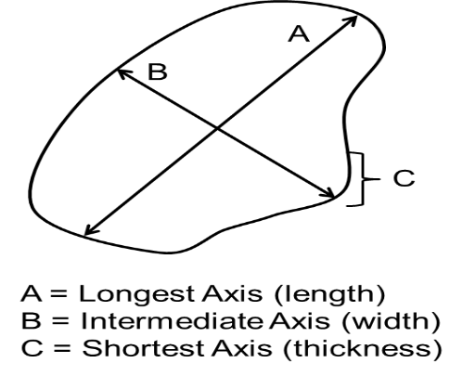
- Tally this sample measurement by the size categories outlined on the data form. Use the Dot/Slash system to record pebble counts, where:
10 = 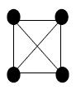
- Repeat Steps 1-5 until a minimum of 100 particles have been observed and recorded. If you reach 100 particles in the middle of transect, continue collecting particles until you reach the end of the transect at the opposite bank.
- Calculate the cumulative percent total for each class size on the Field Form.

2.8 Photo Documentation
A photo record will be able to provide a clear representation of how the stream site has changed over time. It can also provide objective data that will be an important supplement to other water quality data. Documentation of in-stream aquatic vegetation (algae) can be useful for providing general qualitative information on the extent of nutrient impacts to a stream. Landscape photographs can offer a qualitative and, in some situations, quantitative evaluation of the current and trending conditions in a watershed or on a water body. The details contained within photographs provide insight into a number of ecological parameters and environmental conditions that can be logistically challenging to measure, making photo monitoring cost-effective. The parameters and conditions that can be documented with photographs include stream bank erosion, riparian vegetation regeneration, and restoration effectiveness. If repeated for a sufficient period of time, these photos can be used to evaluate resource conditions over time and help inform management decisions.

Supply List:
- Digital camera (GLWQD currently has a black SAMSUNG and a red Canon camera) or county-issued cell phone
- Site Visit Form (example, Attachment A)
- Make sure the camera is in “AUTO” mode.
- Take and photos outlined in the project QAPP or SAP. These might include:
  - Upstream and downstream, standing in the channel
  - Periphyton (algae – aquatic plants) growth in the stream
    - take in-stream photos representative of the algae growth present in the stream reach.
    - remove several rocks from the stream that are representative of algae growth and take photos in a shady spot with a pen or other item for scale.
  - Other photos required for the specific project (repeat photo points, macroinvertebrates, etc.)
  - Your fellow crew members at work, notable changes since your last visit, wildlife, and other things of interest.
- Review all photos to make sure they aren’t blurry, backlit, or otherwise unusable. Take more than one if you feel you can do a better job of recreating the reference photo, but don’t delete any photos. List all photo JPEG numbers on the Site Visit Form.
- Record JPEG numbers for these photos on the Site Visit Form. The JPEG is a 4-digit number that will show on the digital display that overlays the photo when you view the picture in “playback” mode.

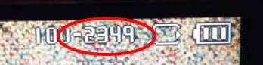
4-digit JPEG numbers appear on the camera screen when in playback mode.

2.9 Macroinvertebrate Samples

The semi-quantitative Environmental Monitoring and Assessment Protocol (EMAP) reach-wide sampling technique, employed by Montana Department of Environmental Quality (MDEQ, 2012) will be used for all District monitoring projects that include macroinvertebrate analysis. Modifications to EMAP methodology in response to certain site constraints are acceptable, provided they are deemed to result in a representative sample. These situations are summarized in the Modifications section.

EMAP Methodology

- Samples will be collected between June 21 and October 1, and as close as possible to the same date each year if the project goals include trend analysis.
- A Habitat Assessment Field Data Sheet should be completed at the time of sample collection (example, Attachment A).
Supply List:
- Transect layout supplies
  - Measuring tape (100ft+, reel-type)
  - Flagging (pre-labeled A-K)
- Sample collection supplies
  - D-frame sample nets (modified kick nets) with 500 µm mesh
  - Macroinvertebrate sample bottles (1 liter wide mouth poly)
  - Lab markers, external labels, clear tape, Parafilm-M
  - Internal labels (paper)
  - 95% Ethanol preservative (in spray bottle and in jug for preservation)
  - #35 (500 µm) sieve
  - Turkey baster, tweezers, plastic spoon
  - Shallow wash tub
  - 5-gallon bucket
- Hip boots or waders
- Site maps/sketches (for repeat visits)
- Site Visit Form and Habitat Assessment Field Data Sheet (examples, Attachment A)
- Coolers or boxes to store and transport samples
- Field notebook
- Camera
Set up the study reach
- Locate a suitable sample reach. Suitability will vary with project goals. In most cases, the sample reach should represent conditions of the stream on a larger scale. Using aerial imagery before the site visit can be helpful, although ground-truthing might reveal the need for modifications to a pre-determined sample reach.
  - An ideal site will have a reach approximately 40 wetted widths long that is free from barriers (culverts, roads, property access issues) or stream confluences. If barriers can’t be avoided, appropriate modifications should be made (see Modifications section).
  - If the site has been sampled before, review any previous data sheets and field notes. Efforts should be made to duplicate the reach and any previous modifications if the goal of the project is to assess change at the site through time.
- Once on-site, calculate average wetted width from five measurements taken in areas along the anticipated study reach, taking care to minimize channel disturbance.
- Multiply the average wetted width by 40 to determine the total reach length. Confirm there is sufficient space for a reach of this length before laying out sample transects. If space is insufficient, it will be necessary to find a new reach or modify the transect layout (see Modifications section).
- Divide the total reach length by ten to determine the distance between 11 transects. These are best determined using a measuring tape and flagged by walking along the contour of the bank before sample collection begins, but can be paced as the sample is composited if conditions make pre-flagging prohibitive. Assign a letter (A-K) to each transect, with Transect A at the downstream end of the study reach (Figure 1).

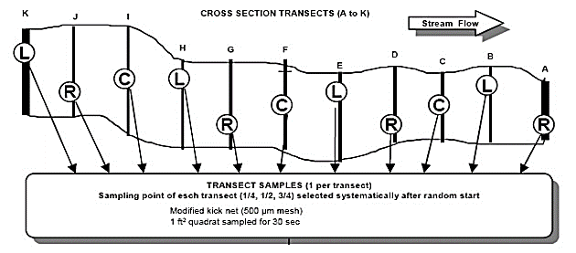
Figure 1. Study reach layout for EMAP sampling methodology (from MTDEQ, 2012)
Determine the sampling position along each transect of the study reach.
- Sample collection should occur downstream to upstream (Transect A → K).
- Samples are collected from sampling points along each transect that are ¼, ½, or ¾ across the wetted width at that transect (or Right, Center, Left), unless modifications for depth are necessary (see Modification section). The sampling position on Transect A is chosen at random. To randomly select the sampling point, use a watch or phone and note the minutes displayed at first glance.
0 – 19 minutes: Right sampling point
20 – 39 minutes: Center sampling point
40 – 59 minutes: Left sampling point

- Subsequent sampling points beginning with Transect B are sampled following the sequence Left, Center, Right, etc. For example, if the sampling point assigned to Transect A was “Center”, then Transect B is assigned “Right”, Transect C is “Left”, Transect D is “Center,” and so on (Figure 1).
Collect a subsample at each transect to create a composite sample.
- Place D-net in the appropriate position on the transect with the opening facing upstream, gently seating it in the substrate as securely as possible so sample contents cannot be carried away under the net.
- Stand upstream of the net and identify a stream sampling quadrant one net width wide and one net width long (1 ft²) directly in front of the net opening.
- Sample the 1ft² area in front of the net by holding the bottom of the kick net against the substrate. Pick up any loose rocks (golf-ball sized or larger) or other larger substrate particles (sticks, etc.) within the sampling quadrant. Use your hands to dislodge organisms so that they wash into the net. Large rocks that are less than halfway into the sampling area are pushed aside. After scrubbing the rocks, set them aside, outside of the sampling quadrant. When sampling a pool with little to no flow, follow the same procedure except use your hands or feet to push the sample into the net. If encountering a slackwater area choked with vegetation, sweep the net through the vegetation for 30 seconds over the sample area.
- Keep holding the net securely in position. Start at the upstream end of the quadrant and vigorously kick the remaining finer substrate for 30 seconds, being careful not to sweep the contents out of the path of the flow into the net.
- Let the water run clear, then pull the net out of the water with a quick upstream motion to wash the organisms to the bottom of the net.
- Return streamside and invert the net into a 5-gallon bucket about ½ full of water. Rinse organisms out of the net using the spray bottle containing 95% ethanol. Inspect the net for clinging organisms. Remove any organisms from the net and place them in the bucket using the spray bottle, turkey baster, and/or tweezers. Carefully inspect any large objects (rocks, sticks, leaves) in the bucket and wash off any organisms into the bucket before discarding them. Remove as much detritus as possible without losing any organisms.
Transfer the composite sample into one or more sample jars.
- Pour contents of the bucket through the sieve. Remove large objects and wash off clinging organisms back into the sieve before discarding.
- Using a turkey baster and stream water, rinse all the organisms clinging to the bucket into the sieve.
- Wash the contents of the sieve to one side by gently swirling the semi-submerged sieve in a plastic tub. Transfer the sample into a jar with as little stream water as possible. The bulk of the sample can be moved to the jar by picking it up gently with a plastic spoon. Carefully examine the sieve for any remaining organisms and use tweezers to place them into the sample jar. Use the turkey baster if necessary.
- Add enough ethanol to submerge the debris in each sample jar as soon as the material from each kick is added to the jar to prevent damage or loss of some taxa by opportunistic predators.
- Repeat steps 8-17 at each of the 11 transects within the study reach, taking photos and filling out any transect-specific data as you go.
Sample post-processing.
- Thoroughly inspect and clean (with stream water) the net after each sampling event to ensure that all organisms have been removed to prevent contamination between sites.
- Important: Fill each bottle only ½ full with sample to leave room for adequate preservative. Use additional bottles as necessary.
- Add 95% ethanol to fully fill the sample jar. Gently agitate the jar to ensure thorough mixing of alcohol and sample. Note: Prepared composite samples can be transported back to the vehicle before adding ethanol if necessary.
- Complete two identical labels (pre-printed on waterproof paper) using a pencil. Place one inside the jar and one on the outside of the jar (secured with clear packing tape). It should include the following information: Sample ID, Sample date and time, Sampler name(s), Sampling method (EMAP Reach-wide), Client and project, Jar # (1 of 1, 1 of 2, etc.).
- Once samples are properly preserved and labeled, cap the jar tightly and seal the jar with parafilm.

Field Replicates

Field replicates are collected to measure total method error and should always be included in the sampling design at a predetermined frequency (usually 10%). Replicate samples are collected by repeating steps 8-19 (above) at another location each transect within the study reach. For example, if the regular sample is collected following the Right, Left, Center pattern, the replicate sample could either be collected following the Left, Center, Right or Center, Right, Left pattern.

Modifications

Below is a summary of foreseeable situations warranting modification to the methodology outlined above. All modifications should be thoroughly documented on site drawings and in field notebooks. A good description of any modifications made will allow them to be accurately replicated (if necessary) at future site visits.

Single-transect Depth and Safety Modifications
If the randomly chosen sampling point (i.e., left, center, right) on a transect is too deep or otherwise unsafe to wade in an otherwise wadeable reach, a safe alternate location up to one meter upstream of that location is a preferred. Alternately, another position (i.e., left, center, right) on the same transect can be used if moving upstream to collect the sample isn’t possible. The initial, randomly selected sampling pattern should be reinstated at the next transect.

Width and Length Modifications
At narrow transects (i.e., between one and two net widths) that were assigned a “Center” sampling point, pick either the “Left” or “Right” sampling point instead. If the transect is only one net wide, place the net across the entire stream width and consider the sampling point to be “Center”.

Total reach length is sometimes confined by property boundaries, confluences, or other barriers. As needed, sample reaches can be uniformly shortened to a minimum reach length of 500 feet when wetted widths dictate greater study reach lengths, provided the character of the shortened study reach still represents average habitat conditions on the stream at a larger scale. This modification should remain consistent through time at study sites for projects with a long-term trend analysis goal.

Multi-channel Reach Modifications
If one of the randomly chosen sampling transect falls within an area with more than one permanent channel of significant size, the L, C, R pattern should be followed considering all the channels as one system. If the sampling transect falls within an area with both a permanent, main channel(s) and a side channel(s) that are significantly smaller (i.e. appear to be seasonal, originating from seeps, backwater dominated, etc.), the L, C, R pattern should be followed only within the main channel.

Stream Crossings within the Study Reach
If a randomly chosen sampling transect falls on or near a bridge, culvert, or road crossing, the transect should be moved up- or downstream only as far as necessary to reach an area outside of that feature’s localized influence. If the feature is known about in advance, the sample reach can be relocated, or the sample transects can be uniformly lengthened or shortened to place them outside of the feature’s influence.

Constraints on Length of Study Reach
If the length of the study reach is constrained by private property boundaries, stream confluences or other barriers, the reach can be shifted (upstream of confluences) or shortened to a minimum reach length of 500 feet, provided the modified study reach is still represents average habitat conditions on the stream at a larger scale. This modification should remain consistent through time at study sites for projects with a long-term trend analysis goal.

References

Barbour, M.T., Gerritsen, J., Snyder, B.D. and Stribling, J.B. (1999). Rapid Bioassessment Protocols for Use in Streams and Wadeable Rivers: Periphyton, Benthic Macroinvertebrates and Fish. 2nd Edition, Report EPA 841-B-99-002, US Environmental Protection Agency, Office of Water, Washington DC.

Makarowski, Kathryn. 2019a. Standard Operating Procedure for Sample Collection for Chemistry Analysis: Water, Sediment, and Biological Tissue. WQDWQPBFM-02, Version 1.0. Helena, MT: Montana Department of Environmental Quality, Water Quality Planning Bureau.

McWilliams, Elizabeth. 2020. Standard Operating Procedure for Total Discharge. WQDWQPBFM-03, Version 1.0. Helena, MT: Montana Department of Environmental Quality, Water Quality Planning Bureau.

Montana Department of Environmental Quality, 2010. SOP for Digital Stage Recorders (Appendix A of M05TMDL02SAP05 Lower Gallatin TMDL Planning Area Flow Monitoring Project 2009-2010 Sampling and Analysis Plan). Document WQPBWQM-007. Helena, MT

Montana Department of Environmental Quality (DEQ). 2012. Sample Collection, Sorting, Taxonomic Identification, and Analysis of Benthic Macroinvertebrate Communities Standard Operating Procedure. WQPBWQM-009. Helena, MT: Montana Department of Environmental Quality.

Peck D.V., et.al, 2006. Environmental Monitoring and Assessment Program – Surface Waters Western Pilot Study: field operations manual for wadeable streams, EPA 620/R-06/003, U.S. Environmental Protection Agency, Office of Research and Development, Washington, DC.

Rantz, S.E. et al. 1982. Measurement and Computation of Streamflow: Volume 2. Computation of Discharge. Geological Survey Water-Supply Paper 2175. United States Government Printing Office, Washington

Appendix A: Example Field Forms

- Site Visit Form
- Stream Discharge Form
- Visual Algae Assessment Form
- Pebble Count Form
- Macroinvertebrate Habitat Assessment Field Data Sheet

1. Example Site Visit Form

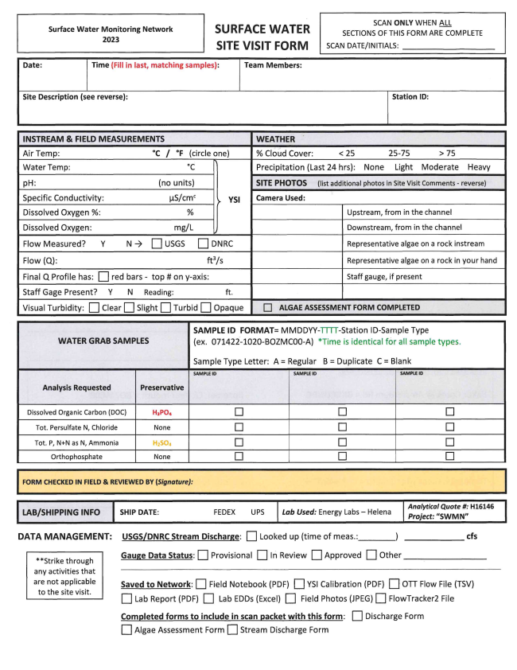
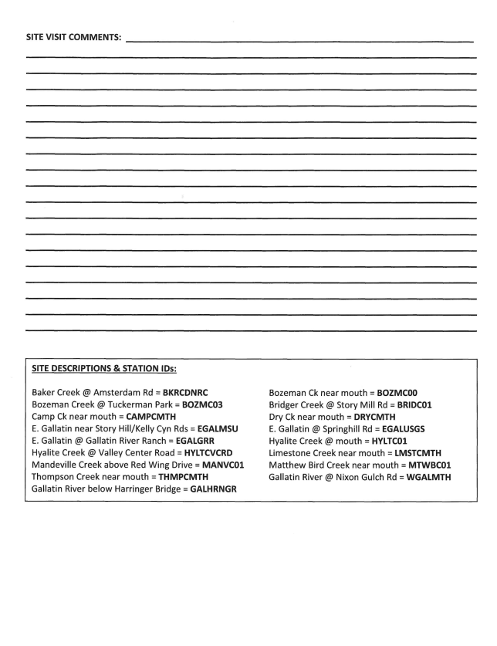
2. Stream Discharge Form
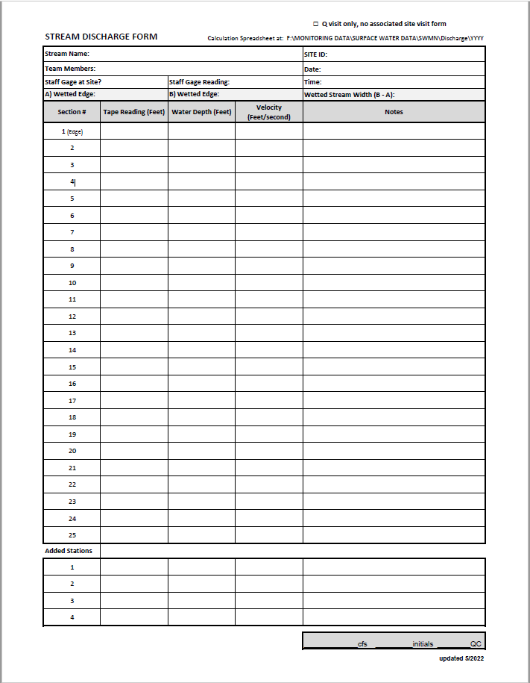

3. Aquatic Plant Visual Assessment Form
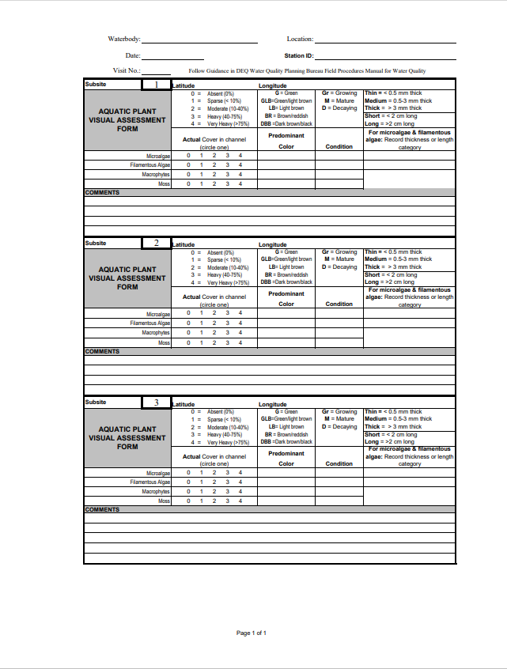

4. Pebble Count Form

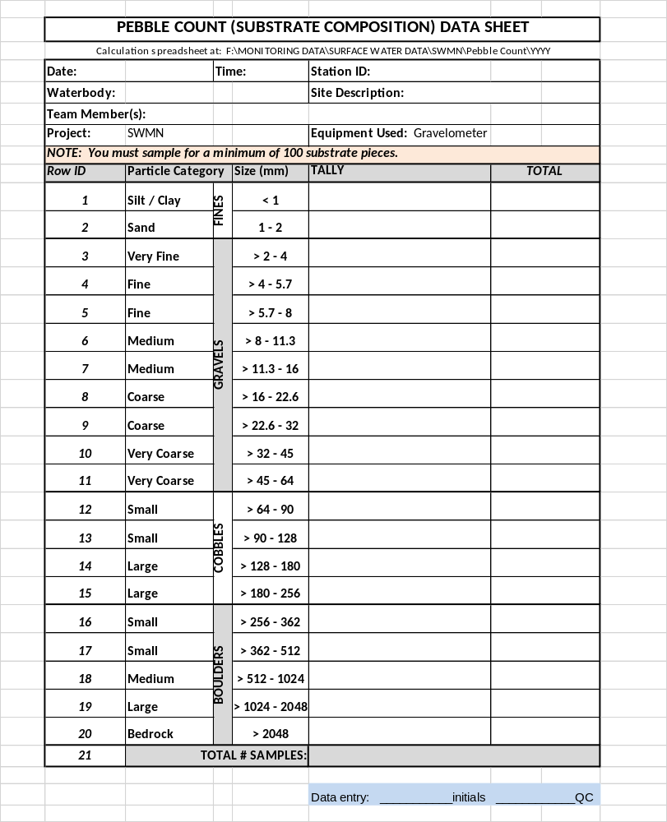

5. Macroinvertebrate Habitat Assessment Field Data Sheet

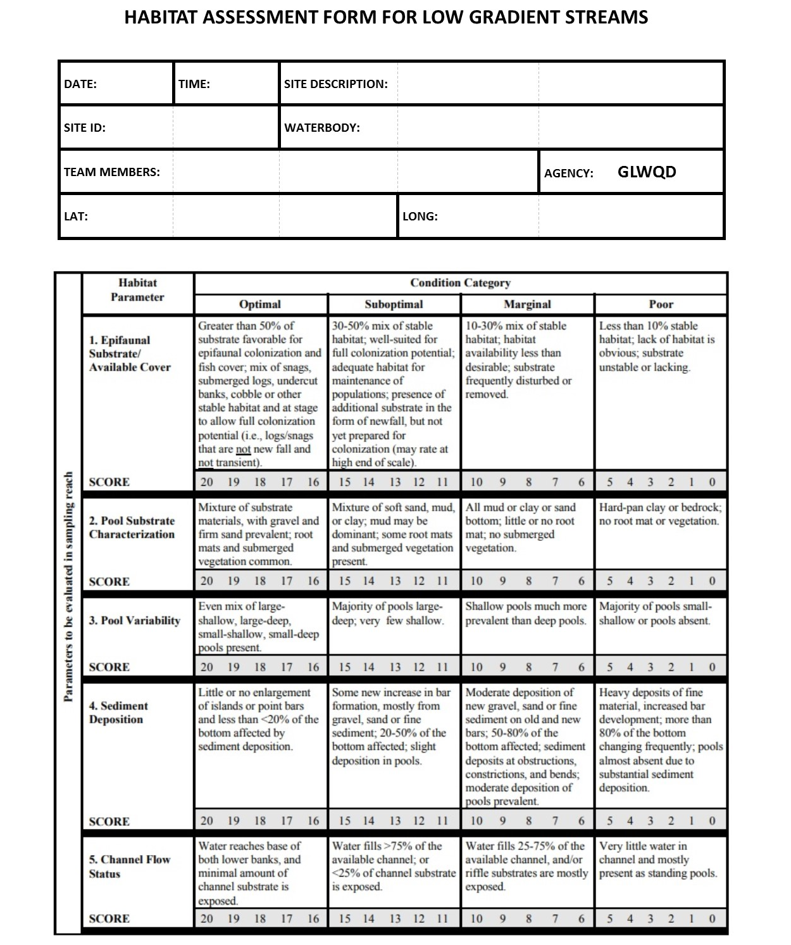

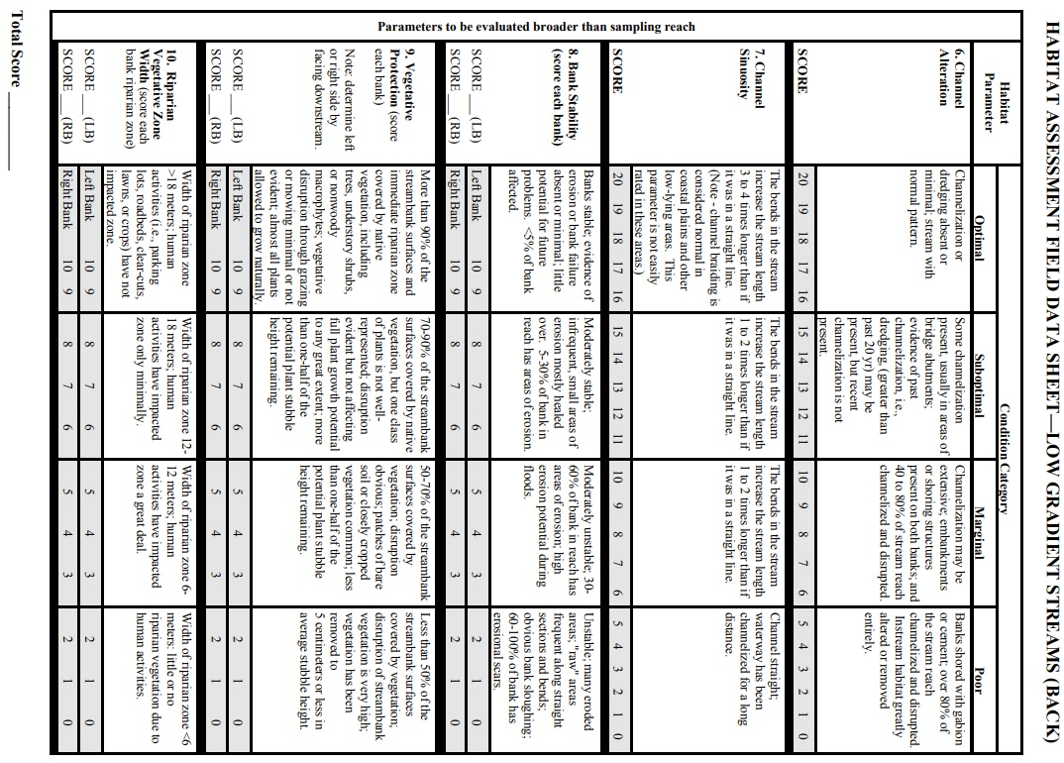

Appendix B: YSI Maintenance & Long-term Storage

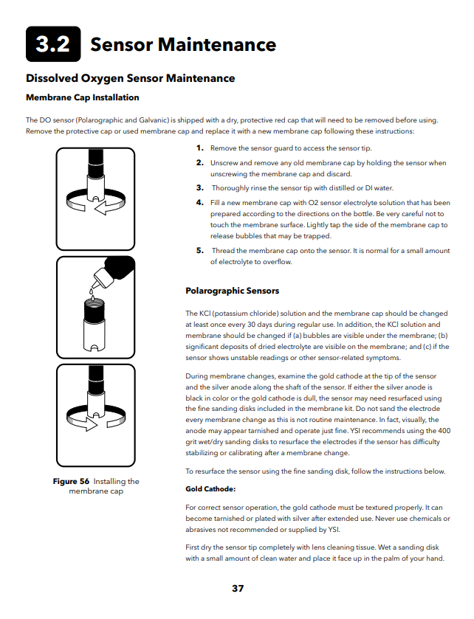

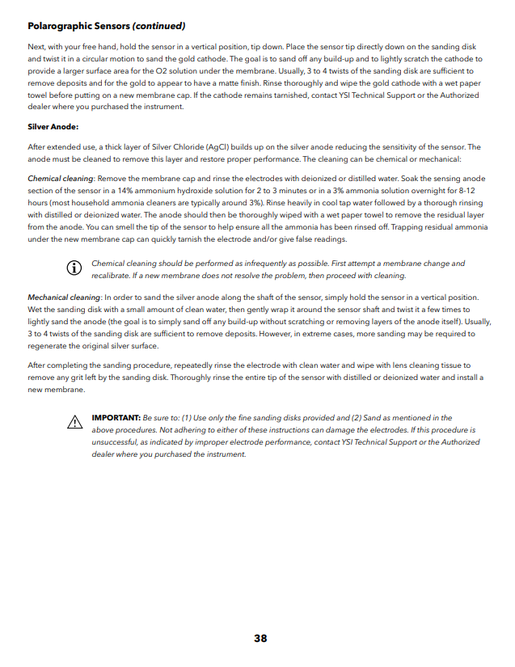
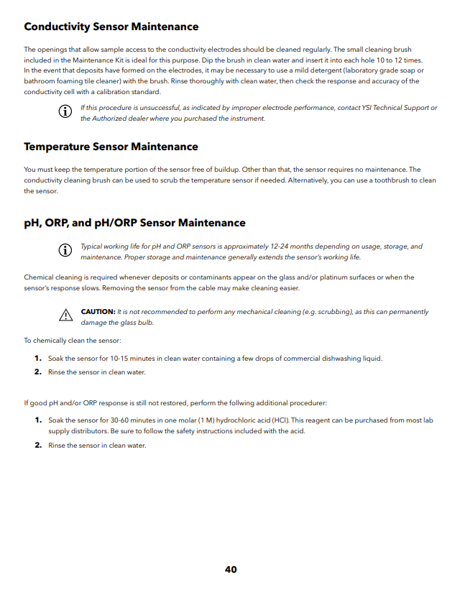

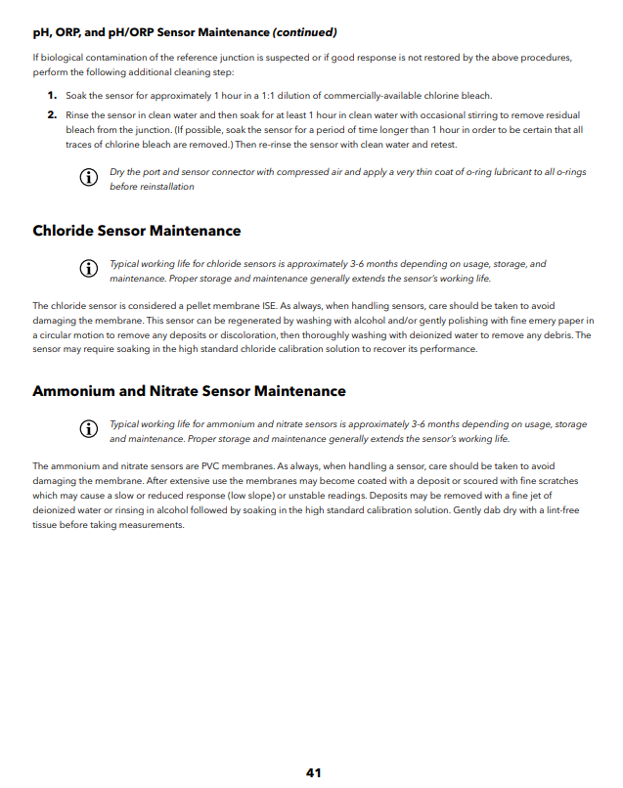

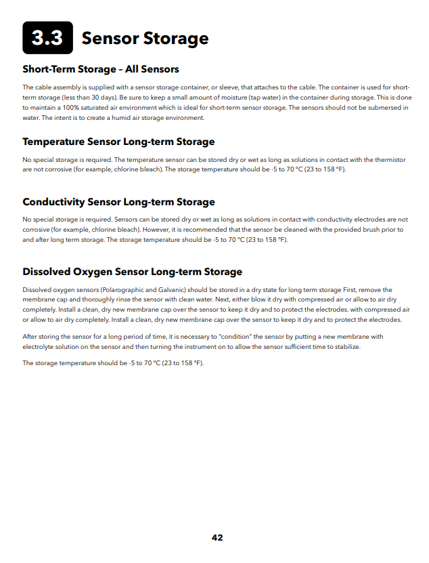

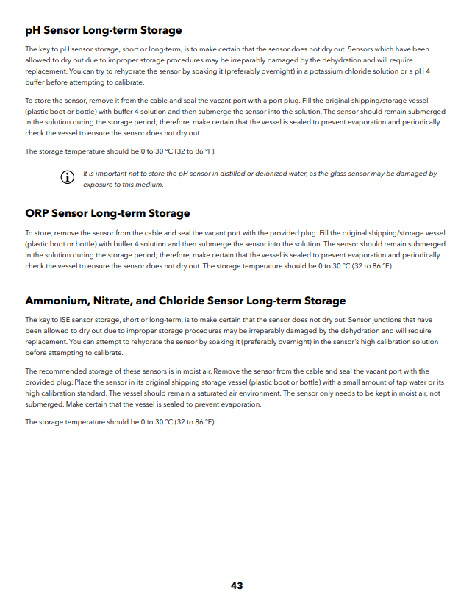

Appendix C: YSI Calibration Instructions and Calibration Log

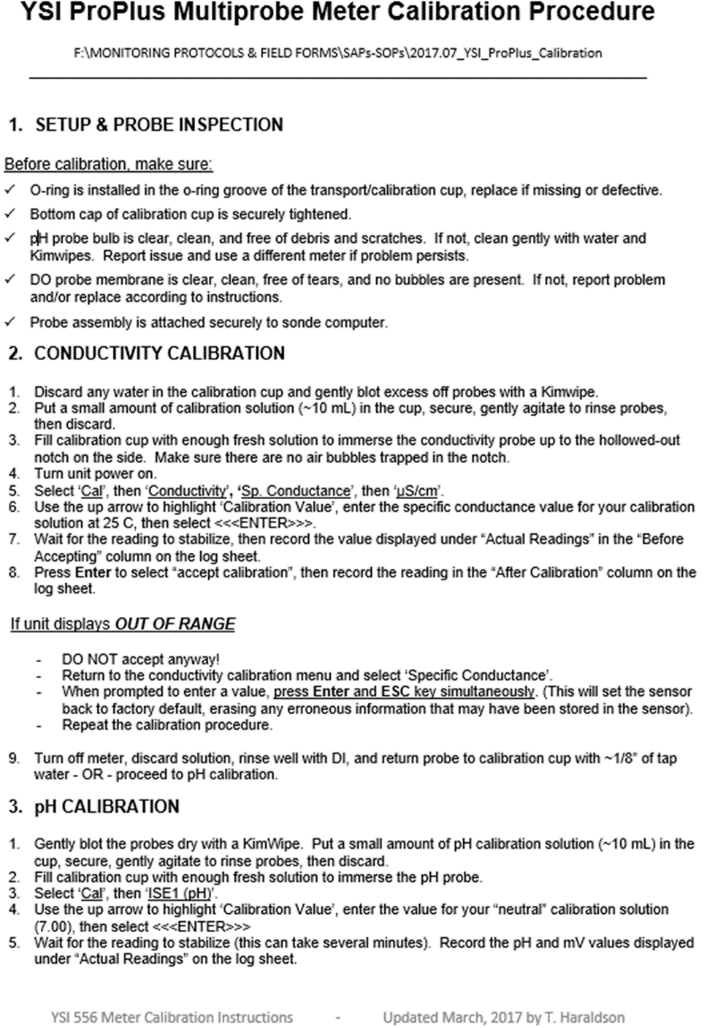
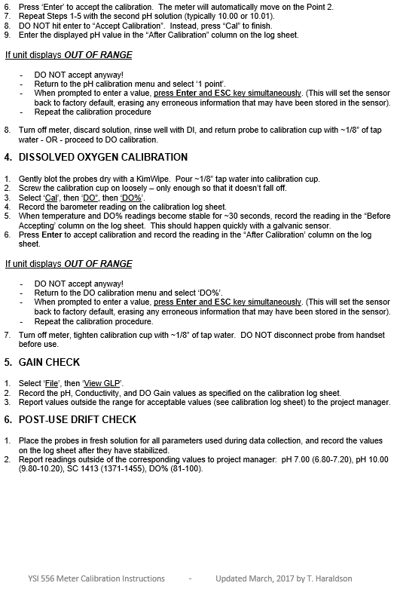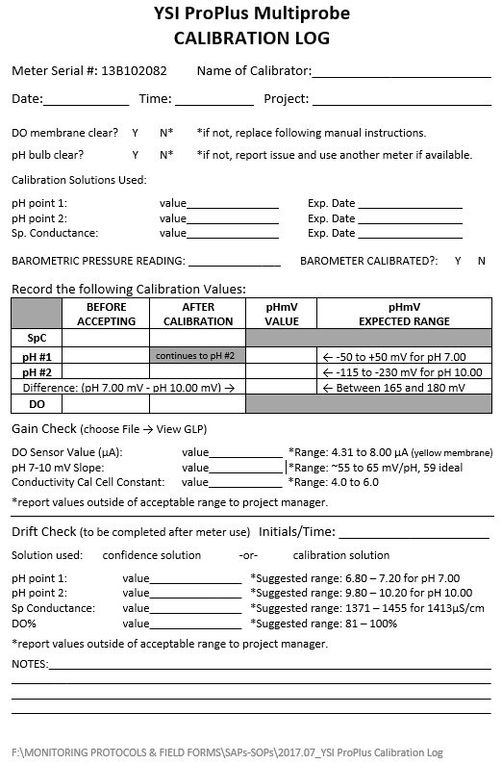

Appendix D: TruTrack Cleaning Instructions

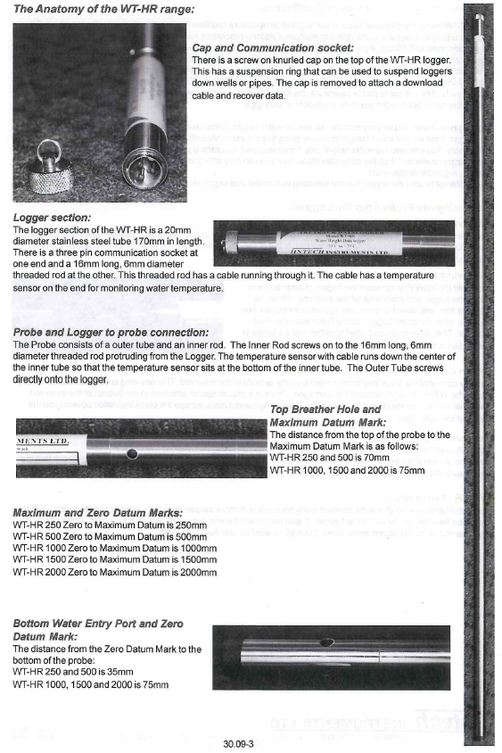

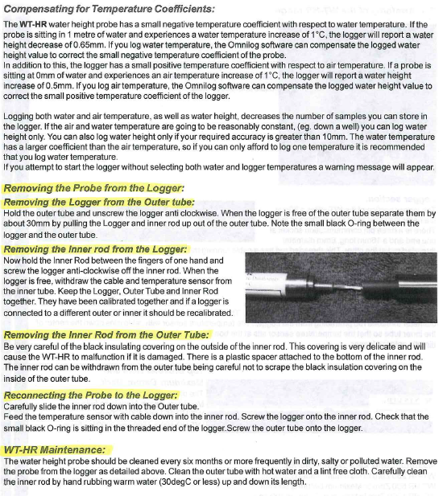

Appendix E: TruTrack Water Level Calibration Instructions

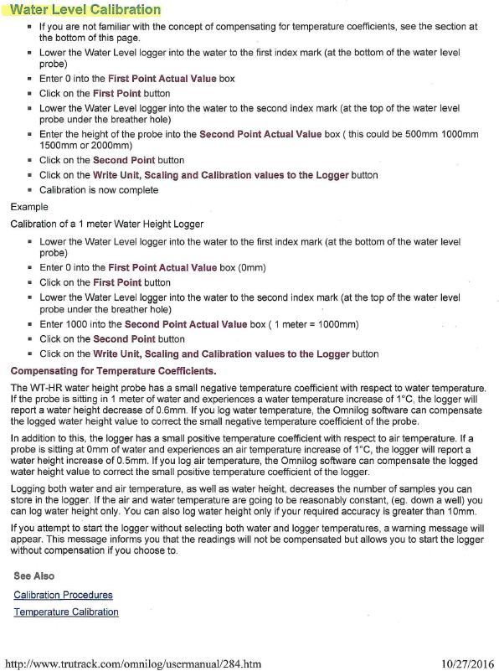

Appendix F: Solinst Levelogger and Barologer Data Download and Compensation Instructions
